THE QUEEN’S COLLEGE

- Address: The Queen's College, High Street, Oxford OX1 4AW, United Kingdom
- Available: 6-10 September (check-in 6 September, check-out 10 September).
- Booking: via congress webpage

The Main Site
All rooms are located on traditional, numbered Staircases and enjoy fine views over the Quads or college grounds. All the facilities of the Main College are close at hand in this historic setting, with the centre of Oxford only a short walk down the High Street.

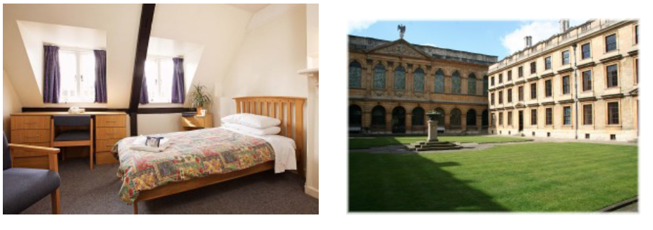

Carrodus Quad, Queen’s Lane
Carrodus Quad is adjacent to Main College on Queen’s Lane. Each room has been fitted with oak furniture and modern en suite bathroom facilities. There is one room equipped for guests with hearing difficulties.
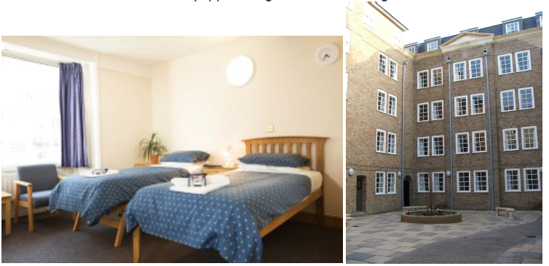

- The Queen’s College offers smart en suite accommodation in the centre of beautiful Oxford. All rooms have tea and coffee making facilities, bed linen and towels, refrigerators and complimentary toiletries, and are serviced daily by our friendly housekeeping staff. Breakfast in our grand Hall is included, and choices can be made from a hearty full English to lighter Continental style options.

- It is a requirement that children are supervised by an adult at all times, and the College and its personnel will not accept responsibility for the actions of unsupervised children.

- The bedrooms do not have televisions, wifi is free and we provide each guest with a unique code.
- The accommodation is student bedrooms, they are of a high standard and are often used for conferences.

- The Queen’s Lane annex is directly adjacent to the college and so a 30 second walk to the hall.
- The Queens Lane annex has lift access and there is a disabled set bedroom and bathroom in main college as well as some ground floor bedrooms.

