BALLIOL COLLEGE

- Address: Balliol College, Broad Street, Oxford OX1 3BJ, United Kingdom
- Available: 6-13 September
- Price: £65 single en-suite
- Booking: directly with the college via the booking form at the bottom of this file
- Contact: Jacqui Fossey, Conference & Events Manager, Tel.:+44 1865 277 676, email: jacqueline.fossey@balliol.ox.ac.uk

Accommodation are both at our main site in Broad Street and at Jowett Walk
Main site: A traditional Oxford college experience
At Broad Street, en suite bedrooms and standard rooms with shared bathroom facilities, usually on a ratio of one bathroom between four bedrooms. All bedrooms have their own washbasins.
Jowett Walk: Modern en-suite accommodation
NOTE: BREAKFAST is served at Main Site (a 7-minute walk for Jowett Walk accommodations)
Jowett Walk was built in 1996. Here we can provide 93 well-furnished bedrooms with shower, toilet, and washbasin in each room. For conferences meals, if required, are taken in Hall at Broad Street, a short walk away. There are also kitchens in the Jowett Walk Building - one between seven rooms - and guests are welcome to use these to make tea, coffee and light snacks.

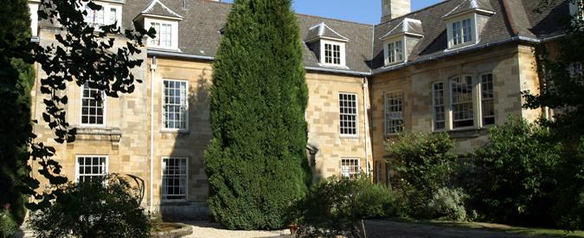

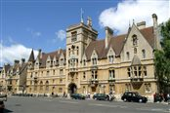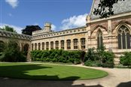

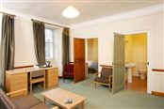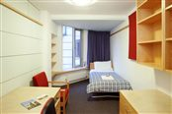

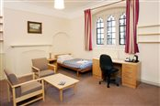

The map shows the route Jowett Walk – main site – Exam School.

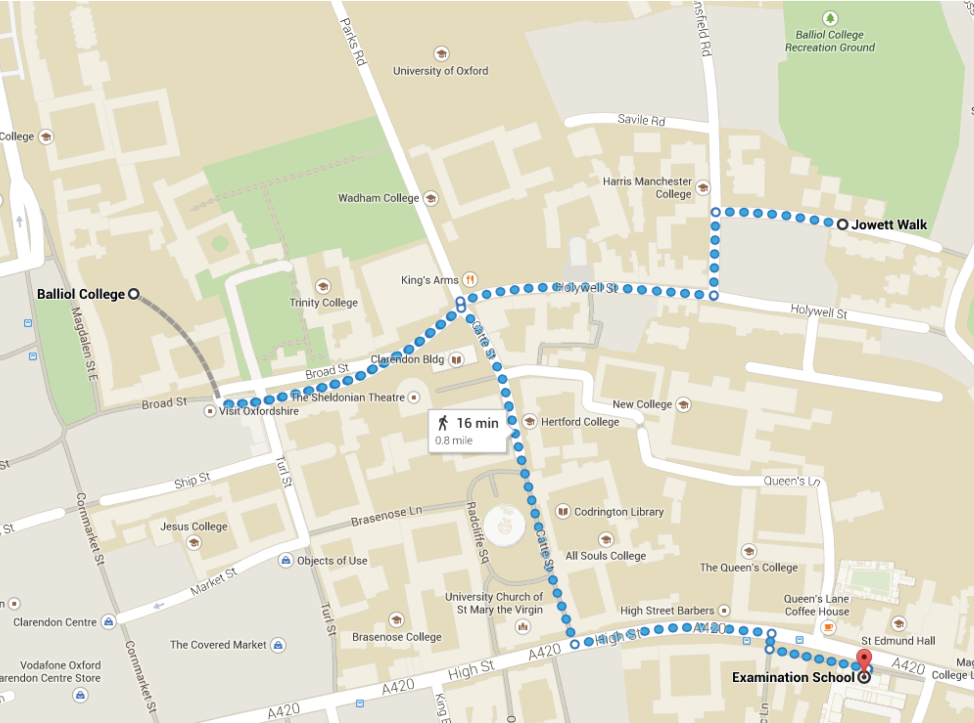

Balliol College, Broad Street, OXFORD OX1 3BJ
Tel: 01865 277 676
Fax: 01865 202 468

BED AND BREAKFAST BOOKING FORM

TITLE

SURNAME

FORENAME
ADDRESS

POSTCODE

CONTACT TELEPHONE NO.
EMAIL
ARRIVAL DATE
DEPARTURE DATE
NUMBER OF NIGHTS
ENSUITE OR STANDARD ROOM
TOTAL PAYABLE
CARD NUMBER
(No AMEX)

3 DIGIT SECURITY CODE
EXPIRY DATE

START DATE

ISSUE NUMBER
RECEIPT?

